**User Manual**

**Software Installation:**

The following technology stack is used to develop this web application.

* Backend: Java Servlet Web Application.
* Frontend: Java Server Pages (jsp), jquery.
* Database: MySql Server Database.

Tools to be installed to build and run the web application:

* MySql server
* Apache Tomcat Server
* Ant build tool

**Step 1:** MySql setup

Make sure MySql server is installed and create a database named restaurant.

1. mysql -u root -p // Log in to mysql shell

2. create database restaurant // Name should be same.

3. exit

Then, run the following command on a terminal: [restaurant.sql is included in submission]

mysql -u root -p restaurant < restaurantdb.sql

This will create a database called restaurant and loads few tables with initial data needed for our application.

**Step 2:** Source code build

Navigate to the root of application folder and run following command.

ant war

After the build is successful, you should see “DelhiParadiseTusharPandey.war” file generated.

**Step 3:** Deployment

Copy the DelhiParadiseTusharPandey.war to your $APACHE_TOMCAT_HOME/webapps directory. Then, start or restart the Apache Tomcat server.

**Step 4:** Launching Web Application

Navigate to http://localhost:8080/DelhiParadiseTusharPandey

You should see the applications login screen.

Administrator login credentials: username: tom and password: qwerty

**Using a web application**

The Restaurant Management system is a web application that is run/hosted on Apache Tomcat server. The application is hosted and can be run at location [**http://localhost:8080/SER515Proj/**](http://localhost:8080/SER515Proj/)once the tomcat server is run.

**User Log In**

The first page of the application Delhi Paradise is the login page. Only the staff (Administrator, Manager, Chef and Waiter) of the Restaurant can access the application using the User name and password.

For example, one of the user that has access to the RMS system Delhi Paradise is of type administrator with user name ‘tom’ and password ‘qwerty’.

The user is supposed to enter the credentials username and password and then click on sign in button to ‘Sign In’ as below:

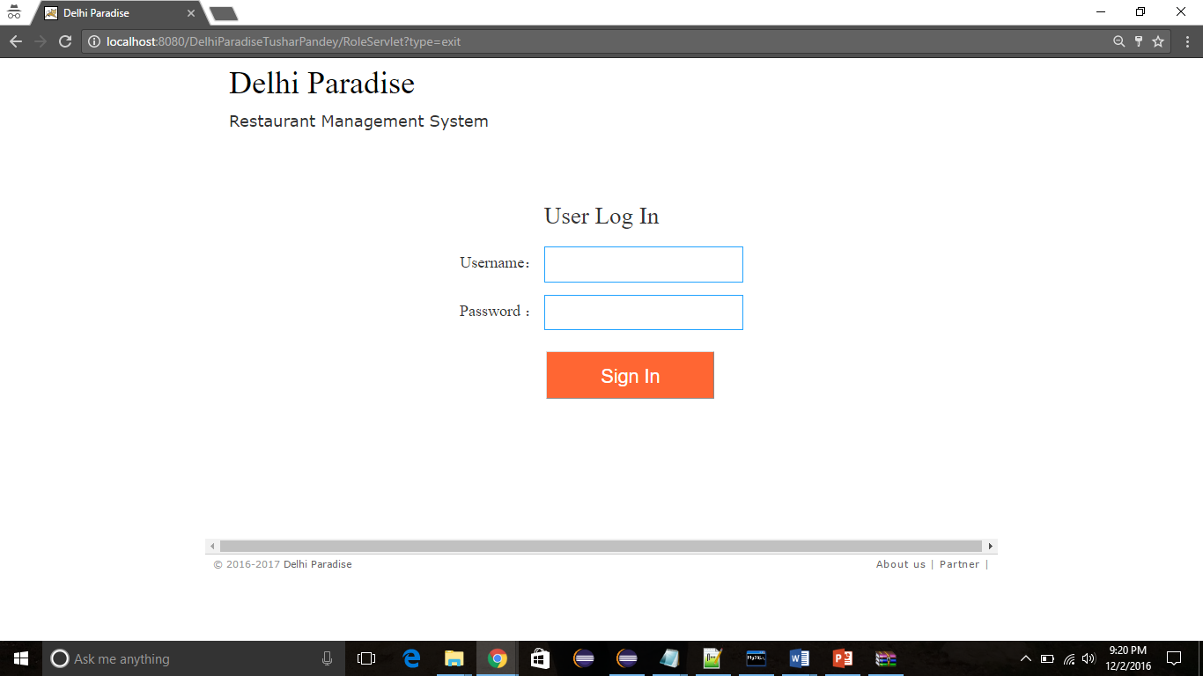

Once the registered user logs in he can see the main screen having 6 navigation tabs; namely to ‘Order’, ‘Team’, ‘Recipes’, ‘Beverages’, ‘Finance’, ‘Customer Order Status’, and ‘Table management’.

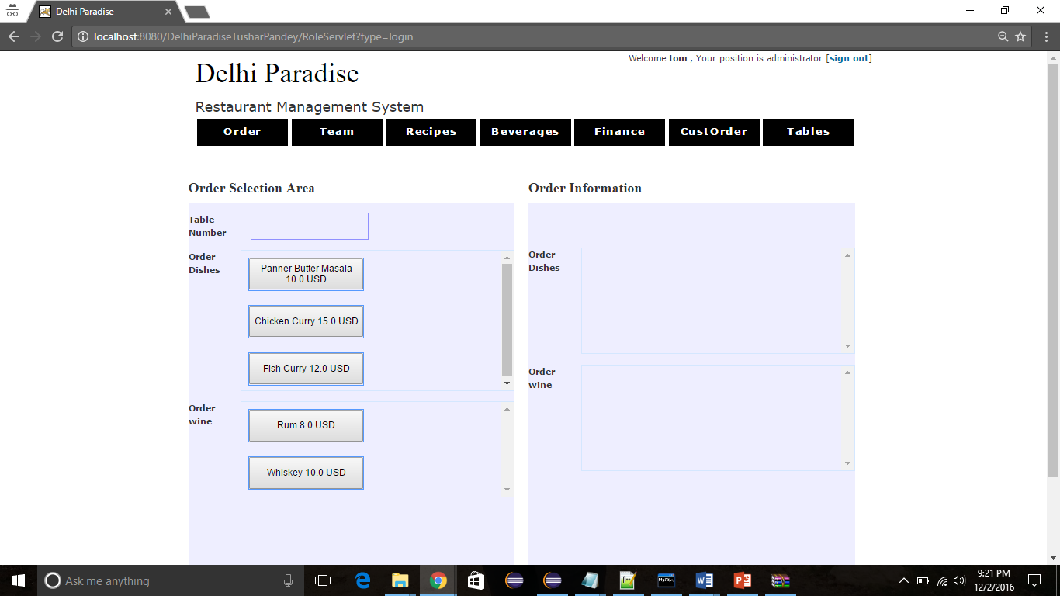

**Take Order**

The user is supposed to take order and record the customer orders over this screen. The screen displays the Table Number that can be assigned to the customer.

The screen presents the different dishes that can be ordered by the customer like Chicken Curry, Paneer Butter Masala, Mixed Vegetable, Mutton Korma, etc.

The customer can order wine also along with the dishes like Old Monk, Bud weiser, etc. These selections can be made on the left panel of the screen under the ‘Order selection Area’. The user of the system can update the quantity of the items selected by the customer by clicking the + or – for signs for adding or deleting the item.

The use can then click the Total button to see the total of the items selected by the customer after taking their order. Once the customer confirms his order the user can submit the order by clicking the submit order button.

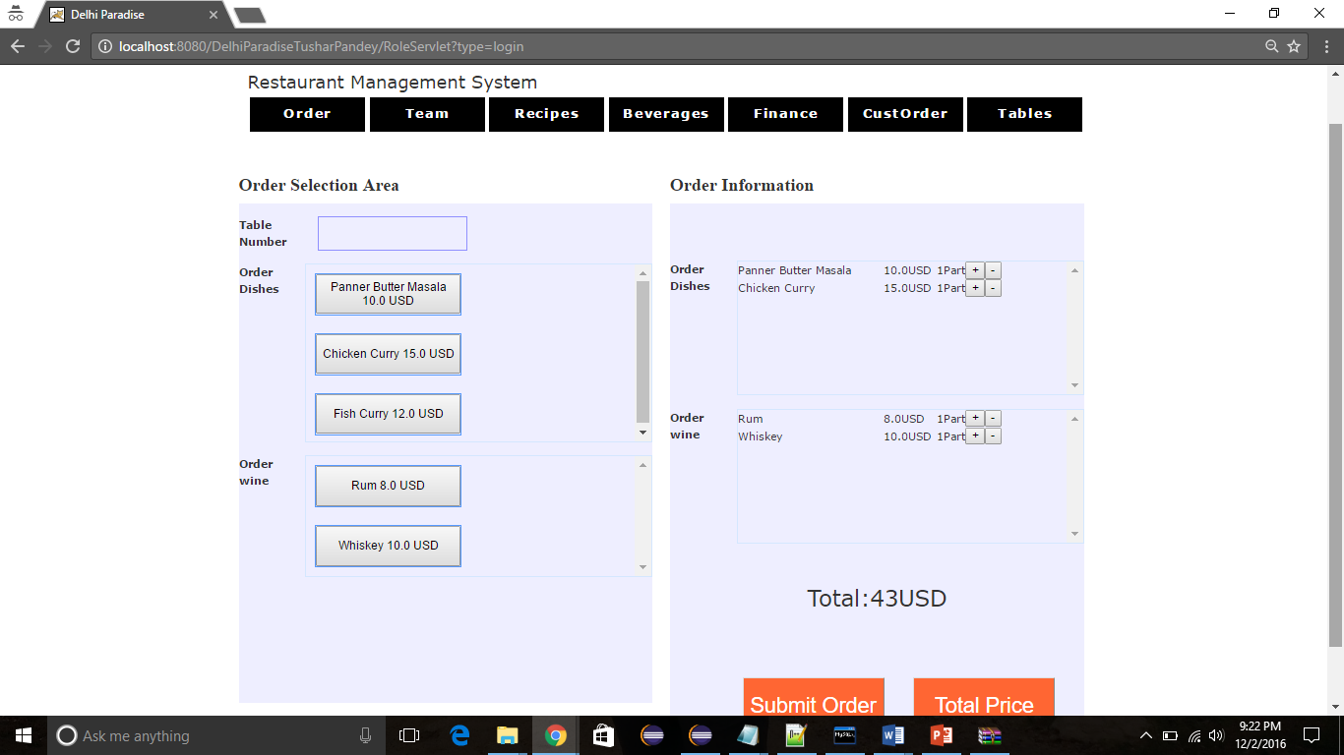

Once the order is complete the user can go to the Customer Order status screen to see the status of the order. The Order status page can be reached through the tab Order Status.

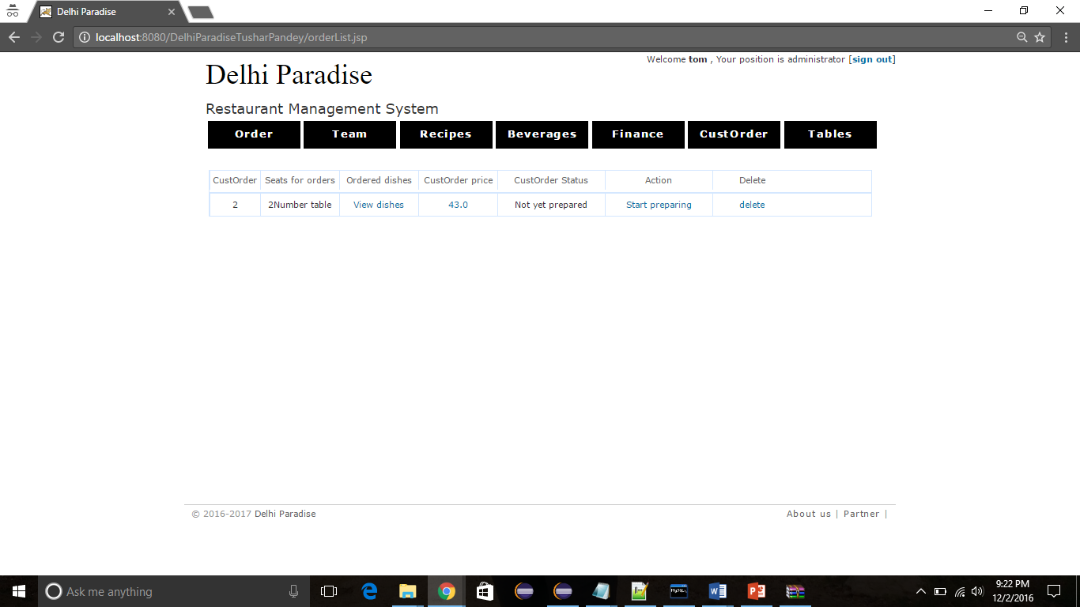

The Action column displays the status of the order like Not yet prepared when the order is not started to be processed. When the order is being worked upon the user can click the button ‘Not Yet Started’ and the action changes to the next one in line that is, ‘Currently Prepared’.

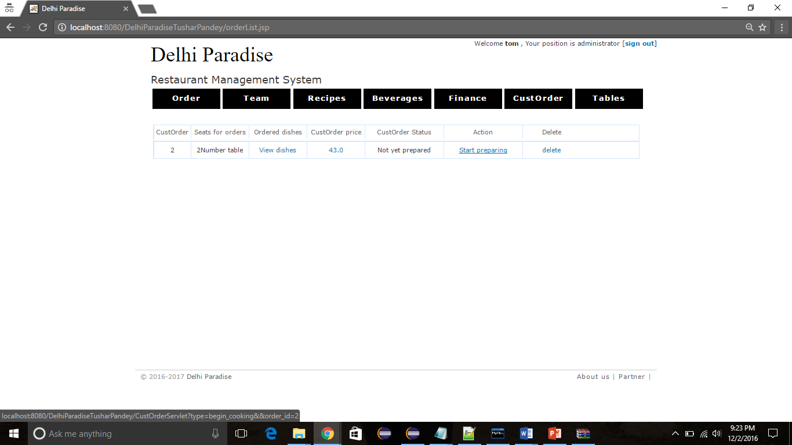

Note: Below is the change in status of Order on clicking the current Action.

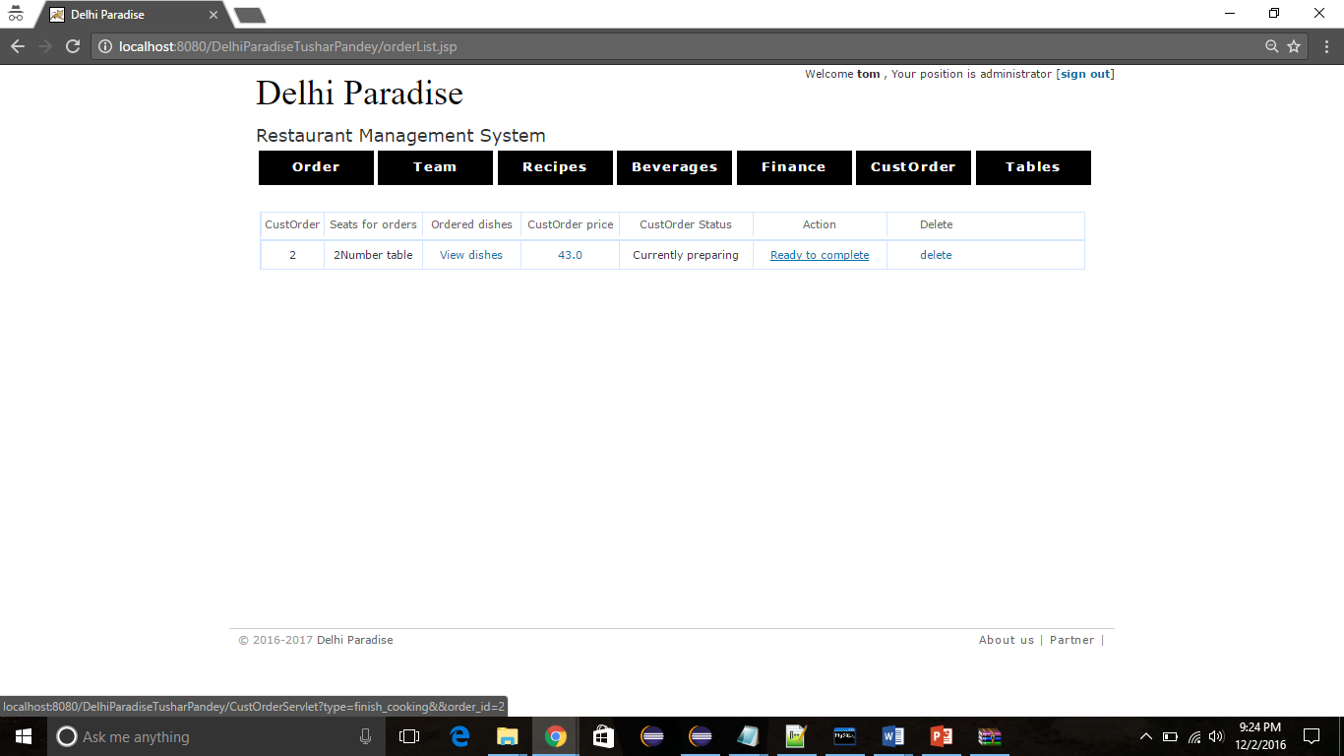

Once the order is complete the status can be clicked to update the action to ‘Preparation completed’.

The user has the option to delete the order once it is completed by clicking the delete.

**Table Management**

The staff can also manage the seating tables by navigating to the table management section by clicking the table tab.

There are different types of table in the restaurant like 2Person table or 4-person table or 8 Person table.

The status of the table can be managed by clicking on idle or occupied based on the availability to the customer. Every table seat has the value occupied or idle.

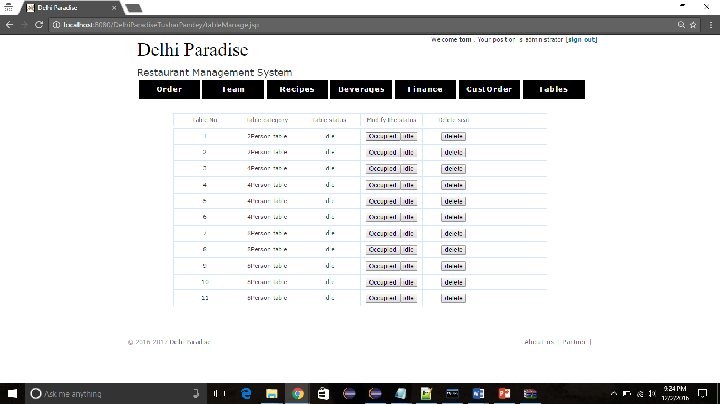

Note: The status of Table 1 changed to ‘Occupied’ in below snapshot.

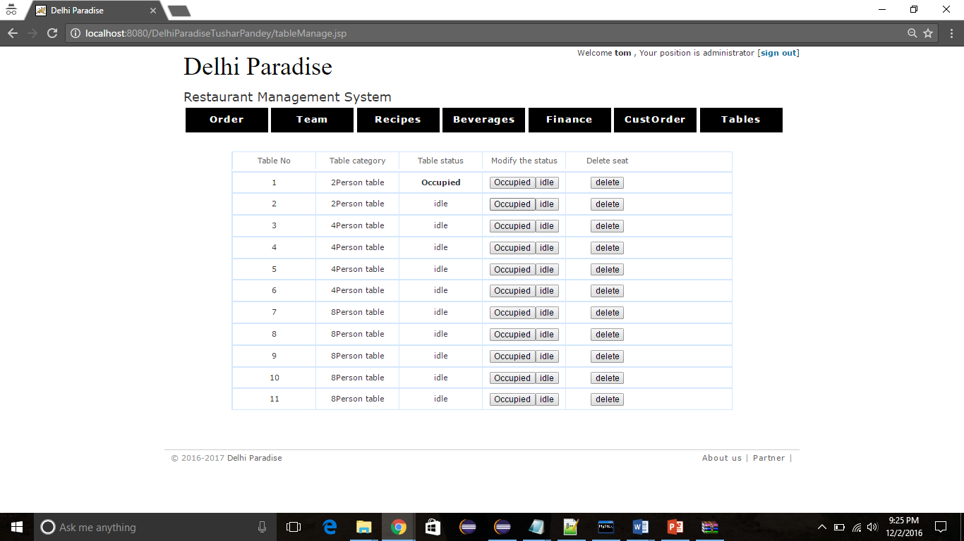

**Team Management**

The staff can be assigned the username and password by going to the Team’ tab. The staff can be either an administrator, manager, chef or a waiter. The staff information can also be deleted using the delete option. Similarly, the user can add any new staff member by clicking the Add.

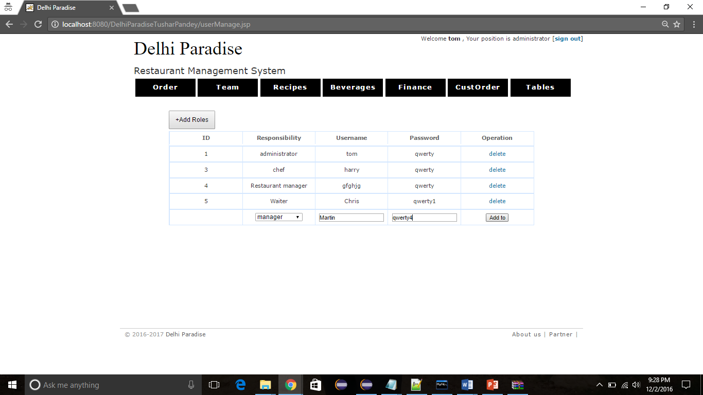

**Recipes Management**

The user can manage the recipes in the system by adding or removing the dishes from the database system. The user can click the Add dishes button to add a dish, enter its name, Price, image of the dish and click save to enter them in the database. Similarly, the user can delete the dish from the catalogue of dishes.

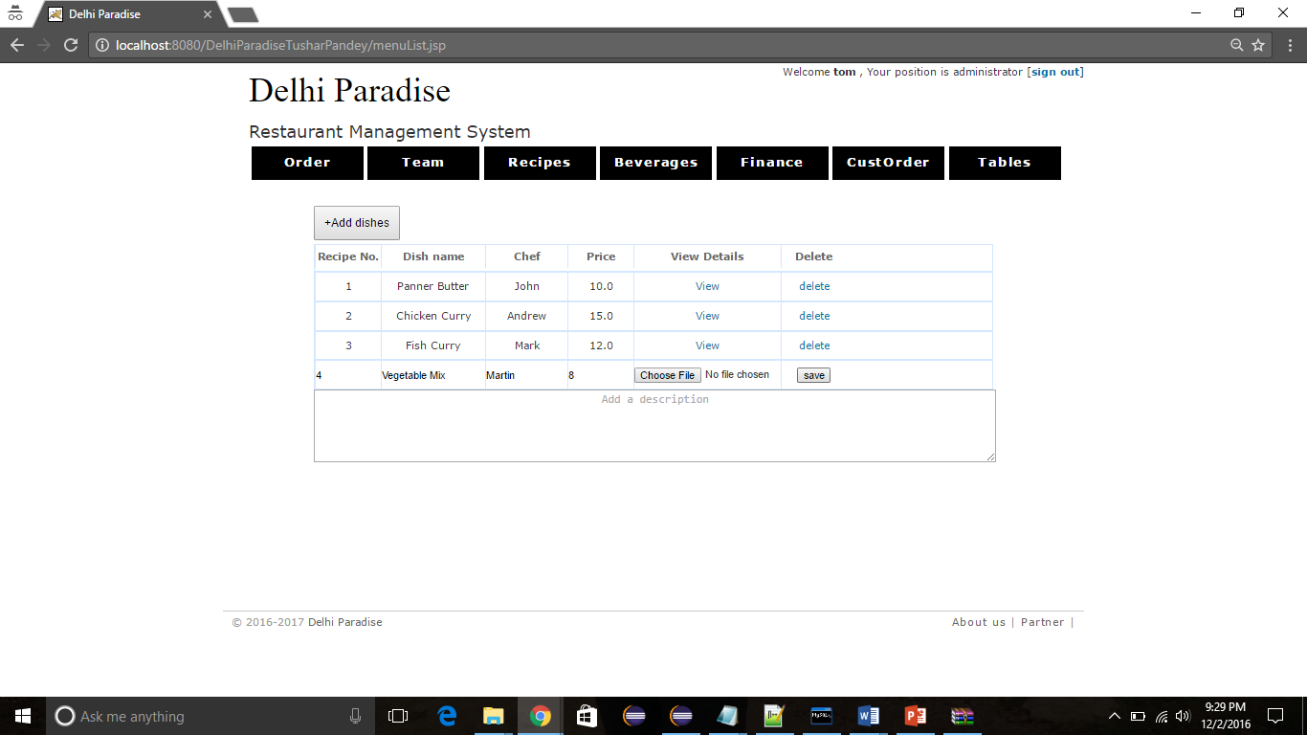

**Beverages**

The user can manage the drinks in the system by adding or removing the beverages from the database system. The user can click the Add drinks button to add a drink, enter its name, Price, image of the drink and click save to enter them in the database. Similarly, the user can delete the drink from the catalogue of beverages.

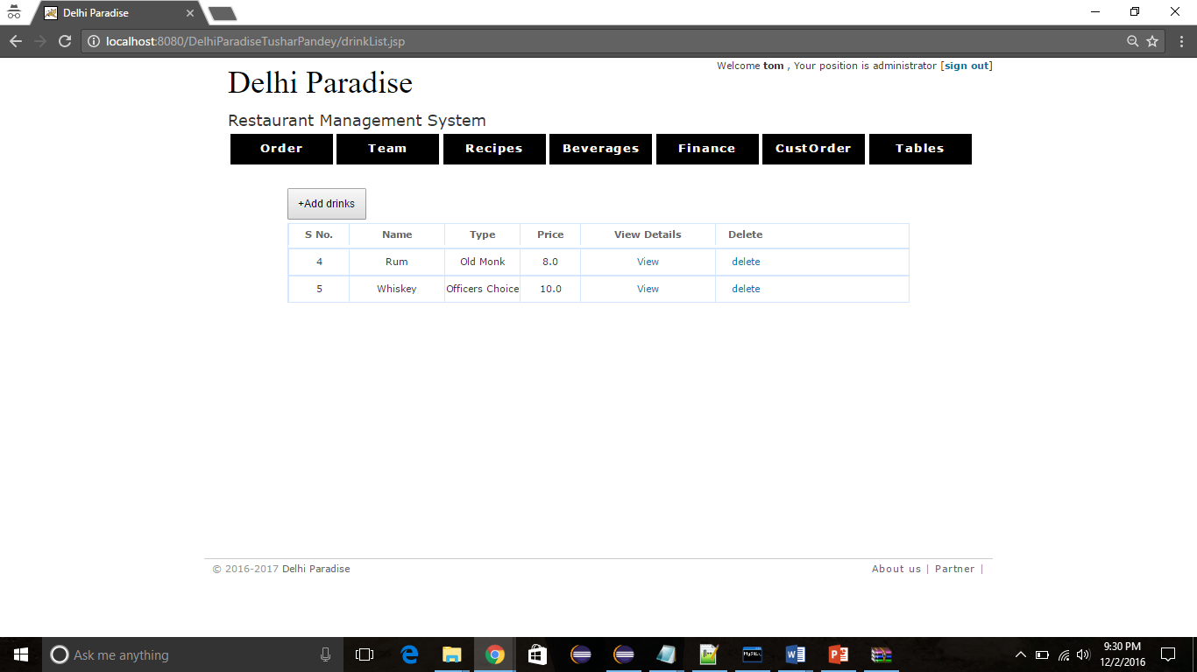

**Finance Management**

All the audit trail of the orders that has been made by the customer are captured and can be viewed on the finance management section under Finances tab. It displays the total income earned by the restaurant through the orders.

